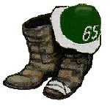The great Class of ’65 Winter ‘07/08 Newsletter

Happy New Year! Hopefully everyone has had a wonderful Holiday and Christmas season and you and your loved ones are happy and well! The days are finally getting longer …. Here’s wishing everyone a happy, fulfilling and prosperous 2008!

This Newsletter (our third this year) will highlight the following:

Comments from our President, Ken McGruther,

A reminder from Jim Griffiths, me and the college about year end tax giving,11/23/2026

A few class notes from Rocks, Murph at Lockerbie,
A reminder of the up coming CarniVAIL, which in a few years has become an avalanche of class and D’s in March (actually 2/29 – 3/2 ) created by Steve and Linda Waterhouse,

Plans for the 65 th for 65s in Washington, DC. Led by Ted Bracken and team,
Speaking of Dartmouth – “Exemplary College,.” Kathy Slattery obit,

Authorship of our class, you won’t believe the richness and diversity!

You’ll get this as a colorful e-mail followed by a no-color paper version a few days later. Please send me your email address if you only get the paper version. If all goes well, thanks to Sotts and a few others, we will expand the electronic distribution this time to over 400 from over 100. Success. So send me your email and news, please.

Please be sure to check the best web site among the alumni classes -- done by our very own Sotts -- John Sottile! There’s a wealth of additional information: htpp://www.biggreen65.com

Many SNAPS to Bob, Steve, Ted, Sotts and our intrepid leader Ken for a lot of the following!

Please send me any comments and suggestions. Keep those cards and e-mails coming!

Carl Boe ( carlantonboe@aol.com )

President’s Corner Newsletter – October 2007

What a weekend in Hanover many of us just shared! The foliage has never been prettier, even in my fondest memories of when we were on-campus. The weather held, with an all-night rain Friday, then a storm that held off until the game was over on Saturday, and then one of those unforgettable perfect New England autumn days on Sunday. The football game was a classic, with the Dartmouth team featuring an old-time “backs go tearing by” offense. The thrilling 37-28 win was not sealed until the two minutes when Dartmouth scored a go-ahead TD, then Columbia gave up a safety with a minute to go.

Even better of course was the number of Classmates who returned for the Homecoming and Mini-Reunion. Classmates from the West Coast, ones who had never been to one before, ones who had been absent for many years, newly weds. We had almost 40 for dinner, including all four of our Class of ‘65 scholars – and class acts each one of them is – as well as Lance Bracken, son of Ted to help keep us young and in touch with students.

Pierce’s continued to be as friendly, homey, informal, comfortable, cozy, and funky as ever, but there is no place better for our cocktail parties, dinners, late-night chats, and the Class Meeting. Many thanks to Bob and French McConnaughey for putting the whole thing together, Jim and Debbie Griffiths for all their help, and Steve and Linda Waterhouse for hosting the Friday night cocktail party.

The Class Meeting covered a long agenda, which will be covered in detail in separate stories here and on the Class Website. Main things were that we’ll be holding a shared 65th Birthday Party next May 2-4th in Washington DC, CarniVAIL in Vail CO on Leap Year’s weekend in 2008, a 2nd Annual GO-GO (Guys Only Golf Outing) in September at Bend, OR, and our Annual Mini-Reunion and Homecoming on October 17-19th. Plenty of opportunities to get together.

We are also now starting to make plans for our 45th Reunion in 2010, and Gary Herbst will be heading up a Committee to start thinking ahead to how we bond to the Class of 2015, beginning when they matriculate in 2011. Boy how time flies! Hope you are all enjoying life as we head toward our collective 65th birthdays.

See you at any or all of the Minis.

Ken McGruther
Class President ‘65

PS All the best for the New Year!

Jim Griffith and I would remind everyone in the last days of the year to consider Dartmouth in your tax strategies for 2007. The College submits:

Giving to Dartmouth through the Dartmouth College Fund is a tax-wise way to make a charitable contribution. If you are considering an end-of-tax-year gift to Dartmouth, the time to act is now. To qualify for the current tax year, your gift must be made by Monday, December 31.
Your gift to the Dartmouth College Fund benefits the immediate needs of Dartmouth undergraduate students including support for financial aid, faculty and academic programs, athletics, and the culture and community of student life at Dartmouth.
Giving to the Fund has never been faster or easier; give online now at www/dartmouthcollegefund.org
Best wishes from the Dartmouth College Fund for a wonderful holiday season.
Sylvia Racca
Executive Director
Dartmouth College Fund

Now, some notes from our classmates:

From “Rocks” Liman. I have already forwarded to Rich, Ken and Marsh:

I had a good time talking to you at the cocktail party at Pierce's before the dinner a couple of weeks ago. Since then I have just missed on buying two great houses in Vermont and have come home to put my own house in Canada up for sale.

I've been wanting to contact three classmates since that Oct. 20th dinner: Rich Beams, Ken McGruther and Marshall Wallach, to follow up some discussions we had and to mail them something. Do you have e-mail and mail address for them, plus phones? It would be great if you could send me anything you have.

Looking forward to living back there again and being closer to all the fun doings, class and otherwise.

Rocks

From Murph:

Hi Carl and Roger,
Brigid and I are just back from six weeks in Scotland, three weeks each in Glasgow (Brigid's home town) and three weeks in Lockerbie. As has been our habit in the three years since our retirements, we did home exchanges whereby the Scots were in our place in Hanover while we were in theirs. Slick arrangement. Lockerbie you will recognize as the site of the 1988 Pan Am Flight 103 crash, when the plane traveling from London to New York was brought down by an (allegedly Libyan) terrorist bomb. All 259 people on board died, along with 11 Lockerbie residents on the ground. Among the victims were our classmate Robert Owens, his wife, and their two daughters. There are a number of memorials around the town, and I'm attaching a picture of the "Garden of Remembrance" which is maintained by current Lockerbie residents in honor of the victims. There are many similarities to the Vietnam Memorial, obviously on a smaller scale but no less an emotional experience. I thought this might be of interest to classmates.

Murph
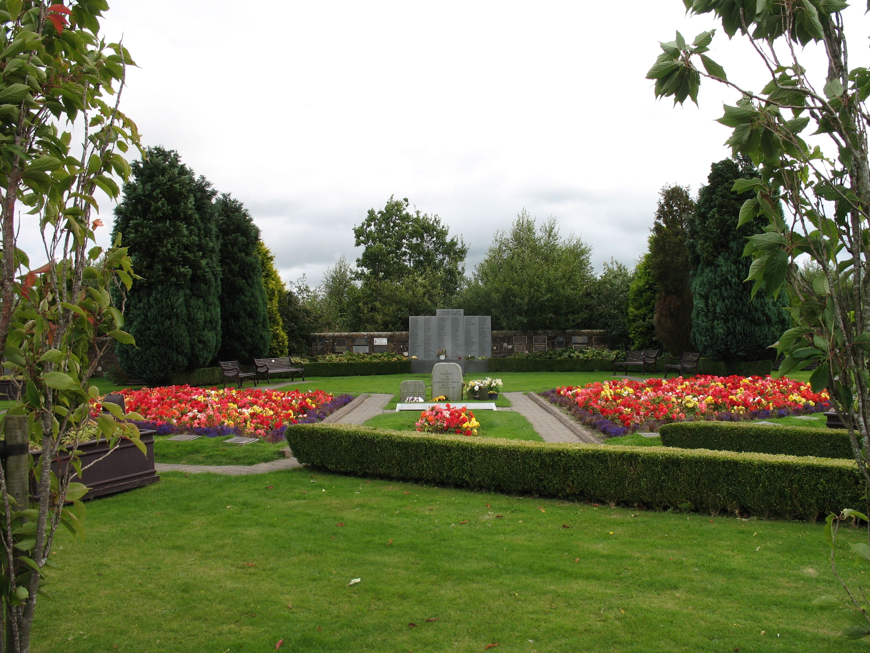

CarniVAIL from Steve Waterhouse:

Hi folks,

Just to keep those of you who are not resident in Vail aware of the mountain's progress for the new ski season... The mountain saw a small amount of snow last night, and are opening up today, November 21, for the first few ski runs of the season.... We include the "Mountain Open" press release below. This url will get you to the web cams operating right now to show some of the white stuff on the mountain! http://vail.snow.com/winter/#a=tm|b=webcams

To help those alumni from Dartmouth, Tuck School, Dartmouth Medical School and Thayer School who are looking to book hotel rooms for CarniVAIL, Feb 29-March 2, 2008, we have also included some more information on changes this year in Hotels and other mountain facilities....

The year 2008 is the time to "Leap to CarniVAIL"!

Best regards from Vail,
Steve Waterhouse '65, T'67, President, Dartmouth Club of the Vail Region, and the Officers/Executive Committee of Gerry Huttrer '60, Alan Danson '60, Joe McHugh '60 T'61, Sara Jardis '93, Diane Boyer '78, Jane and Tom Healy '56, Jim Butterworth T'91, Stacey Sapp '93, Sarah '95 and Peter Millett DMS '95, Steve Cheheyl '67, Alana Hanks '05 and Richard Pomboy '60

Four New Developments Will Greet Vail Winter Guests
New retail shops, restaurants and lodging at four new properties will be ready to serve Vail's residents and guests this winter. The late summer completion of One Willow Bridge Road, located at the corner of Willow Bridge Road and East Meadow Drive, featured the opening of the Marketplace on Meadow Drive. The unique retail concept offers upscale groceries and gourmet food for dine-in or carry out. Across the way, the Vail Plaza Hotel & Club on Vail Road is poised to open and will feature two new restaurants and a lounge, in addition to new hotel and residential units. At the top of Bridge Street, Mountain Plaza, the skier services facility developed as part of the Front Door project, will greet guests with new amenities just steps from the Vista Bahn chairlift including a new coffee house meeting place, rental and retail shops, adult ski school, lift tickets and ski storage. Finally, the much-anticipated Arrabelle at Vail Square will open its doors in December and will change the face of LionsHead with a welcoming public plaza, new shops and restaurants, skier amenities and an ice rink. For details on Vail's ongoing renewal, visit http://t.pm0.net/s/c?31.3iuq.14.1kaz.60.
FOR IMMEDIATE RELEASE: VAIL MOUNTAIN’S 45TH SEASON GETS UNDERWAY WEDNESDAY, NOVEMBER 21
Vail, Colo. – Vail Mountain is set to open for its 45th season on Wednesday, Nov. 21 at 9 a.m. The resort will offer skiing and snowboarding on Born Free trail which is served by the Born Free Express Lift (Chair 8) in Vail Square/ Lionshead. The Eagle Bahn Gondola will offer scenic rides and the Marketplace restaurant at Eagle’s Nest will be serving lunch. Vail Snowsports School guests can take advantage of adult and children’s group and private instruction through the Vail Square/ Lionshead location and the Small World Nursery at Golden Peak will provide child care. Lift tickets on opening day are $59 for adults, $49 for seniors and $39 for children 12 and under.
Through an extraordinary effort by Vail’s snowmaking crews, a very good early season snow surface awaits skiers and riders on Born Free trail. Mountain operations crews are looking forward to the cold temperatures and natural snow that are forecasted over the next week and anticipate moving as quickly as possible to expand into new terrain. The resort is targeting to have the recently upgraded Little Eagle Lift (Chair 15) open for beginners by this weekend.
Recent investments on the mountain and in the community will debut this winter. The resort list includes:
- Highline Lift (Chair 10) and Sourdough Lift (Chair 14) were replaced this summer with new high speed quad chairlifts. Both lifts will expedite the trip to Two Elk Restaurant, China Bowl and Blue Sky Basin and cut ride times in half.
- The Arrabelle at Vail Square, a RockResort, is set to open in January 2008 at the foot of the gondola. It will feature 36 luxury hotel rooms and up to 50 additional condominiums; a traditional Germanic Glockenspiel including a celebration of snow; a 10,000 square foot full-service RockResorts Spa and signature dining at Centre V, a French-brasserie inspired mountainside restaurant.
- Golden Peak Children’s Center and Small World Nursery were completely remodeled to increase space for the ever-popular 3-6 year-old program. With its comprehensive children’s learning area and the popularity in children’s private lessons, the upgraded space will also allow for easier and faster registration for parents.
- Mountain Plaza in Vail Village is the new skier and snowboarder services facility that is scheduled to open in December. The building is set at the base of the Vista Bahn and includes the Express Lift Coffee House, equipment rentals and retail, adult ski school, lift tickets and ski storage.
In addition to skiing and snowboarding, a vacation to Vail includes numerous activities far beyond the ski slopes. Guests also can enjoy gourmet dining at a variety of new restaurants, rejuvenating spa treatments and unique shopping with signature gifts just in time for the holidays. Vail Snow Daze kicks off a winter full of events. The weeklong festival takes place Dec. 3-9 and includes headliner concerts with Ziggy Marley on Dec. 6 followed by Social Distortion on Dec. 7 at the Dobson Arena. Ludacris and The Roots take center stage Dec. 8 for an outdoor concert at Ford Park. Also don't miss the Dummy Gelunde Championships on Dec. 8, snowball eating contests, a fashion show, and 1,000 Snowflakes of Vail throughout the week. View the complete schedule at www.vailsnowdaze.com.
For more information about Vail Mountain, call the Resort Information and Activities Center at 970-476-9090 or visit www.vail.com.

Plan now for 65th for 65s in Washington, DC chaired by Ted Bracken:
A Planning Committee of Bob Blake, Rich Bloch, Don Boardman, Mark Efron, Pete Frederick, Bob Koury, Bob McConnaghey, Ken McGruther, and chaired by Ted Bracken will be putting together a memorable weekend to celebrate our 65th birthday year on the weekend of May 9-11, 2008 in the beautiful and historic city of Washington D.C. The weather at that time of year should be spectacular with spring in full bloom. While specific events have yet to be finalized, we have arranged for a block of rooms at two convenient downtown Washington hotels, one of which will also serve as the site of an Friday night cocktail reception and welcome for all attendees. Details on hotel reservations will be available soon - or you can opt for a stay over with classmates in the area or make your own hotel arrangements. Some of the possible events being discussed: a historic walking tour of Old Georgetown, a gala dinner event with entertainment at a special venue, and a Sunday morning event in remembrance of our deceased classmates. Other optional activities might include museum and monument visits, a golf outing, a Washington Nationals game in the new stadium on Sunday afternoon, and much, much more. Washington is full of so many wonderful things large and small that are often missed by the typical tourist. We Washingtonians hope you will come and let us show you why we love living here. To help us with planning, please send an email to Ted Bracken at bracken@jhu.edu with an indication of your attendance plans: WOULDN'T MISS IT, PROBABLE, or MAYBE, and the number in your party. More detailed information will be forthcoming in future Class Newsletters and our Website.

SPEAKING OF DARTMOUTH:
December 10, 2007
__________________________________________________________________
NEWS:
DARTMOUTH IS AMONG A GROUP OF "EXEMPLARY" COLLEGES AND UNIVERSITIES FOR JUNIOR FACULTY SATISFACTION, according to a recent survey conducted by the Collaborative on Academic Careers in Higher Education (COACHE), Dartmouth was named exemplary in six out of twelve categories, including tenure practices, clarity, and reasonableness; effectiveness of key policies; overall nature of work; teaching; research and support services; work and family balance; compensation; culture and collegiality; and global satisfaction. Numerous questions in each category were assessed on a one-to-five scale to establish levels of satisfaction.
http://www.dartmouth.edu/~news/releases/2007/12/06.html

Kathy Slattery Phillips, 1952-2007, Longtime Sports Information Director
Courtesy: Dartmouth
LEBANON, N.H. -- Kathleen Slattery (Kathy) Phillips, 55, the director of sports
information at Dartmouth College and well known in New Hampshire women's
amateur golf for more than three decades, died on Wednesday, November 21, at
Dartmouth-Hitchcock Medical Center after a brief illness.
Following graduation from Syracuse University in 1974, she was a reporter in
the Lebanon area for the Manchester Union Leader and New Hampshire Sunday News
until she became Dartmouth's assistant sports information director in 1977. In
1983 she assumed the duties she has held for the past 24 years.
"The Dartmouth community is terribly saddened by Kathy's passing," said James
Wright, president of the College. "What a tragedy. Kathy brought energy and
enthusiasm and professionalism to everything she did. She cared deeply about
student athletes, the coaches, and the Dartmouth athletic programs. We send
condolences to her family and join in their grief. She will be sorely missed by
us all."
"The feeling of sorrow, and sadness is overwhelming within the department and
college, as I am certain it will be with everyone who was touched by Kathy on a
professional and a personal level," said Josie Harper, Dartmouth's director of
athletics and recreation. "The Dartmouth athletic family has lost a dear friend
and a wonderful colleague whose dedication and professionalism was unmatched.
For 30 years, Kathy has worked tirelessly on behalf of Dartmouth and thousands
of our student-athletes."
Donations may be made to the Kathy and Corey Phillips Family Fund, to benefit
Kathy's young stepchildren, care of Mascoma Savings Bank, 67 North Park St.,
Lebanon, N.H. 03766.
****************************************************
Patricia Fisher '81
Director, Class Activities

Authorship in our class. Please send me more examples. Thanks to Jim Hamilton for these wonderful summaries: 

