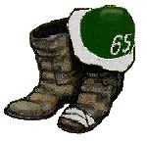 The Great Dartmouth Class of ’65 Summer 2007 Newsletter

I hope everyone is having a great summer!

This Newsletter will highlight the following:
The upcoming Hanover Mini – October 19 – 21 – Bob McC. sign up now!

Thoughts from the “Big Mac”, Ken McGruther’s Presidents Corner;

Notes from a few of our friends – Marshall Wallach, Bob Wooster, Rocks Liman, Judy Townsend, Mike Crawford, Max Hermes, Larry Hunt, Dan Corbett and Ed Keible;
College news – Jim Wright support for the troops, New Englander of the year;
OOH Minis – lots of great meetings! Bob Blake is expanding this with success!
Birthday ’65 -- 65th, Washington, DC, early May, 08. See below!

If you haven’t recently checked out our web site, I would encourage you to do so. Sotts has done a fabulous job. Go to www.biggreen65.com ! There is a lot of information beyond the newsletter. This will also come in paper form to all including those whose email I don’t have yet.

Please send me feedback and your email. There is a spot in the web site to send me a note or send it to me directly – carlantonboe@aol.com Many thanks. Carl

Hanover ’65 Mini, Oct. 19 -- 21, 2007, Bob McConnaughey, sign up now!
The Class of 1965 Hanover Mini-Reunion will be held over the October 19-21 weekend. Headquarters will be Pierce’s Inn in Etna with our traditional hosts, Cindy Pierce and her husband, Bruce Linglebach.
This is the Dartmouth Homecoming weekend, and will include the Dartmouth Night parade and bonfire Friday night and football against Columbia on Saturday (order tickets from the College – 603-646-2466).
Steve and Linda Waterhouse have invited all ‘65s to their home in Hanover for wine and hearty hors d’oeurevres on Friday evening both before the parade and after the bonfire.
Directions to the Waterhouse home at 5 Clement Road: The house is one of only two houses that back up to the College end of Occum Pond on Clement Road – that is, the opposite end of Occum Pond from where the Hanover Golf Club and the Dartmouth Outing Club buildings are.
For the five minute walk to 5 Clement Road from the front of the Hanover Inn, proceed on North Main St (with the College green on your right) toward Baker Library. When you pass the library on your right (and Tuck Drive on your left), you will be walking on North Main St./Rope Ferry Road. In our time, Dick’s House fronted on Rope Ferry Road. Continue on North Main St./Rope Ferry Road past Webster Ave. (Fraternity Row) and past Choate Rd. on your left.
The next left is Clement Rd. (Be careful – it is Maynard Rd. going to the right toward the new McLaughlin dorms and the White Church).
5 Clement Rd is the second house on your right after you have turned onto Clement Rd. It is white with dark green shutters.
* * * *
Enclosed with this Mini-Reunion memo is a Reservation Form for the weekend to be sent directly to Pierce’s. Please don’t fail to send in the form to let us know what events and meals you will attend and the number in your party for each. This information is important so the class can adequately plan and provision for the weekend.
If you plan to stay at Pierce’s, please remember that there are a limited number of rooms. Call (603-643-2997) or e-mail (piercesinn@valley.net) to make your reservations. To assure that the Class will be able to continue using Pierce’s as our Mini-Reunion headquarters, it is important that a sufficient number of classmates stay at Pierce’s.
If you are staying at Pierce’s, please include with your Reservation Form a check made out to Pierce’s for $50.00 as a deposit.
Those staying at Pierce’s will pay the balance of their bill – room and meals – on Sunday morning.
If you are not staying at Pierce’s, please include with your Reservation Form a check for the total cost of meals you will eat at Pierce’s (breakfasts are $10.00 and the Saturday night dinner is $36.00 per person).
You will reimburse the Class of ’65 for other costs. Please see Bob McConnaughey before you leave Hanover to be sure you are paid up with the Class.

We look forward to seeing you in Hanover!

Schedule of Activities
Friday, October 19
6:00 PM – Wine and hearty hors d’oeuvres at Waterhouse’s
7:00 PM – Parade & Bonfire:

(assemble on Lebanon St. near St. Denis Church
on Jim Griffiths’ hay wagon)
8:30 PM – Wine & hearty hors d’oeuvres at Waterhouse’s
Saturday, October 20
7:30 AM – Breakfast @ Pierce’s
10:30 AM – Tailgate Brunch near Sphinx
12 noon – Football v. Columbia
6:00 PM – Cocktails @ Pierce’s
7:30 PM – Dinner @ Pierce’s (followed by entertainment)
Sunday, October 21
8:00 AM – Breakfast @ Pierce’s
9:00 AM – Class Meeting @ Pierce’s

Registration
Please complete this form and mail (with a check to Pierce’s Inn for amounts due) to:

Pierce’s Inn
261 Dogford Rd.
Etna, NH 03750
(603-643-2997)
piercesinn@valley.net

If you have a room reservation at Pierce’s, please enclose your $50.00 deposit check made out to Pierce’s Inn and provide the information requested by the form.
If you do not have a room reservation at Pierce’s, please enclose your check made to Pierce’s Inn for the correct amount to pay for your party’s meals at Pierce’s (prices set forth below) and provide the requested information.
You will be billed by the Class of 1965 for costs of the event Friday evening, for the Tailgate Brunch, and for the cocktail party on Saturday before dinner.

Name: __________________________________________

Others in your party: _______________________________

Phone No.: _______________________________________

E-mail address: ___________________________________

Names of people staying at Pierce’s: ______________________
____________________________________________

Friday, October 19: Number at Waterhouse’s _____________

Saturday, October 20: - Breakfasts @ Pierce’s ($10 each)____________
- Tailgate Brunches ($ TBD)_________________
- Dinners @ Pierce’s ($36 each)______________

Sunday, October 21: - Breakfasts @ Pierce’s ($10 each)_______________

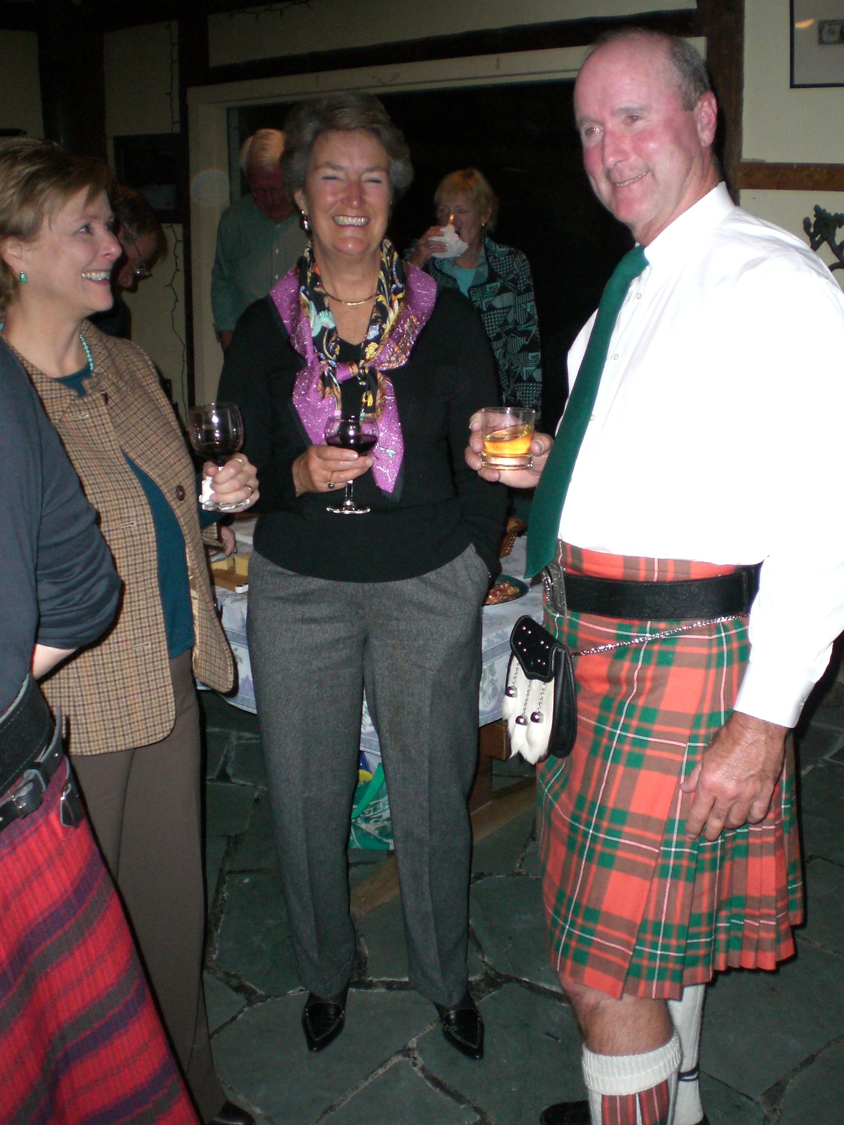The presidents corner – Thoughts from the “Big Mac:”

For the 16th consecutive year the Class of 1965 Executive Committee met at the lovely oceanfront home of Bill and Sue Webster back on July 16th. The day was lovely, the food and company was excellent, and the business of the Class was conducted crisply.

The highlight of the meeting was a conference call with Ted Bracken, who will be coordinating our "65th Birthday Bash" to be held in the Washington DC area on the first weekend of May next year. (What could be better than ALL of us "65s" co-celebrating our 65th birthday together?) A lot of ideas were exchanged during that conf-call. Ted is already moving out with plans, and will be forming an Advisory Committee in the near future.
Much of the other business also concerned future Mini-Reunions: Our 29th annual one in Hanover on October 19-21st, the next Carni-Vail over Leap Year's Day weekend in 2008, and a "2nd Annual" guys only golf outing probably in Oregon late next summer.
On the business side, Treasurer Bob Murphy continues to keep things in fine order financially. Those paying Class dues were up and we are accruing a balance that can be invested back into projects and activities. Jim Griffiths again led us to a fine year in the Alumni Fund Drive meeting all goals, including 50% +1 in terms of total donors. Overall, the figures show that we are gradually meeting our overall goal for this 5-year period in the Class's history of "Increasing Participation."
Next step is for many of you who have not yet attended Minis to come out and join and enjoy your classmates. See the articles and invitations elsewhere in this Newsletter, and as the man said, "C'mon down!"
Ken McGruther '65

Interesting notes from a few of our classmates (Keep those cards and letters coming!):

Marshall Wallach (11/06):
Hi Carl,
As we “gray,” I suspect many of us will go “bionic” with replacement knees, hips, shoulders, et al. I recently had a full left knee replacement (excessive squash, I suspect!). I writeto share the insight (to me, anyway) that this operation is a major inconvenience – out of work for 4 weeks, no driving for 2 months, no flying for 3 months, (risk of blood clots). All goes well and I am happy to have done it … but … some planning is required to deal with the post-op convalescence. Regards to all, Marshall
mwallach@wallachcapital.com
205 Franklin St., Denver, CO 80218

Bob Wooster (11/06):
Moved from Cape Cod to FL, near Ocala, with wife Bethie. Still working in Home Building Business. Son Todd, a senior at Dartmouth. Regards, Bob.
1164 N. Hunt Club Drive, Hernando, FL 34442, 352-560-7676
rawooster@tampabay.rr.com

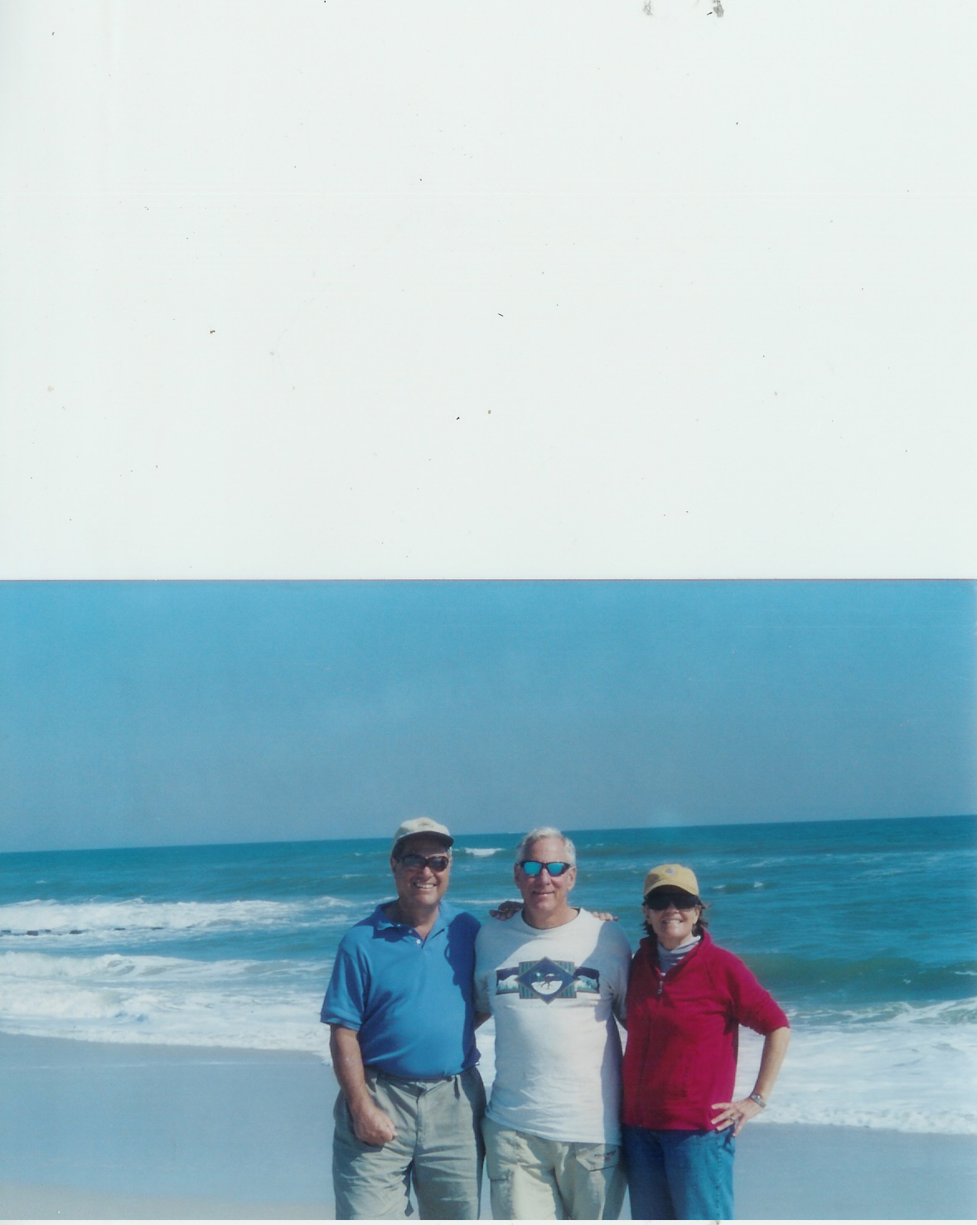 Claude Limon:
Carl -- sorry about my bad handwriting in last February’s message from the mid-west after our X-C ski race. My printing is clumsy but perhaps is more legible (Who is he kidding!).
Another trip! This time to the NYC area and New England in October, a festival of fall leaves and nostalgia. I live in a New-England-like setting in Medford, Ontario, nowm south shore of Georgian Bay, two hours north of Toronto, but still enjoy the cider tang of a genuine New England fall.
We began our tour in Surf City, NJ, with old friend Jim Kingsdale, fellow ’65, at his gorgeous new beach house one dune from the ocean. Jim and his wife Nina (see picture), catered perfect 80 degree for us on our Columbus Day arrival.
Then a day/night in Manhattan with them at their 72nd St apartment, followed by some charmed days of car and bike touring of all my sacred sites in Westchester, the Catskills and New England. Great to still feel connected to to the people and places of my deep pas, especially now that I have lived in Canada for over 33 years.
My tour companion and chaperone is Jaqcqueline Davis …. She knows more about my “roots” and why I act as young as I do. Claude (Rocky).
climan@rogers.com

Judy Townsend (wife of Wes), early 2007:
Thanks for continuing to send me the newsletter. Although Wes has been dead now for 3 years, we met, fell in love and got engaged while he was at Dartmouth. ….
Wes was a quiet, brilliant man. His contributions to our everyday lives enormous: he co-invented, among other things, the touch screen used world-wide. He loved Dartmouth. Judy
105 Whitaker Street, apt.201, Savanah, GA 21401 judy_townsend@yahoo.com Cell 732-604-1595
P.S. Judy please consider joining us at the Mini in Hanover at Pierce’s!

Frank Hermes:
Hi Carl,
After 35 years of corporate life, I "sort of" retired two years ago. "Sort of" because I now work for myself in a venture called the Library Leadership Network. Combined with some consulting activities, LLN keeps me fairly busy--the LLN mission is to help those who run libraries to run them better. It is thus a sharing of ideas and experiences among library directors and other industry leadership types. The main service is an e-publication, and I am happy to report that among my many contributors I have Jeff Horrell, the Dartmouth College Librarian. Anyone interested in checking out LLN can go to our website:
www.libraryleadership.net
Other than that, Cindie and I still live in Westerville, Ohio, just north of Columbus. The weather is nothing to write home about, but otherwise we enjoy the area, which features a pretty good college football team (even better than the Big Green!). Our son Jim (class of '91) and his wife Lisa reside in the Washington D.C. area with our two grandsons (6 and 2), while our daughter Liz (Bates '93) and her husband Kier now live in Dubai. We visited them in March and saw the UAE and Egypt--very interesting trip!
My best wishes go out to fellow '65's. One of these days we will make the trip back to a mini-reunion.
Best, Max
5835 Lake Forest Way, Westerville, Ohio 43082, 614-901-0335

Mike Crawford:
In July, 2004, I retired after almost 37 years as a civil servant at the Naval Satellite Operations Center. I enjoyed the work for most of my career, but by the end it became very stressful trying to do so much more with so much less.
I am now playing tennis several mornings a week and enjoying life.
Mike Crawford, 2330 Bayhill Court, Oxnard, CA 93036 mikec10s@adelphia.net

Larry Hunt (early 2007)
Dear Carl, Odds and ends ….
- My daughter Caroline Hunt (’00) received her masters degree in education from Stanford in June (a year ago) and became engaged in September.
- In addition to my duties at my law firm, Sidley Austin, where the obscure group I founded about 30 years ago was named #1 in the US in hedge fund legal advice, I recently joined the National Board of the Melanoma Research Foundation, an advocacy group for the 5 th most common cancer. (I am a melanoma survivor.)
- My stepson’s wife Jocelyn Werner, MD produced a baby boy, Simon and my stepson, a corporate lawyer in San Francisco, is already plotting his son’s future career in ice hockey.
- My son, Darwin Hunt, a Middlebury senior, received his third NCAA ring last month, as Middlebury won its 3 rd consecutive NCAA D-III Hockey Championship last month. Anyone in NH or Vermont will be able to find me at the Middlebury Arena this winter – it’s a 3 hour drive from Hanover.
- My daughter, Laura, lives in Los Angeles, aspires to a career in film production, and works as a lead assistant for the Alliance for Children.
- My wife, Katherine, and I spent 2 weeks in Rome and France in October, where we visited my “French Family” in Montpellier : e.g. where Mosby Harvey (died in ’98), Tom Marks, Alden Thayer, Mike Merritt and I went in the fall of ’63. That term, followed by my Reynolds Scholarship, gave me the impetus for cross-border legal work, including the creation of the “mutual offset” system.
Larry
1796 Aberdeen Dr., Glenview, Il 60025 847-486-9388 lhunt@sidley.com

Dan Corbett:
I just visited Cince and Paul Pringle in San Francisco along with Debra and Will Migely '66 across the Bay. It was a couble reunion of rugby teammates and US Navy shipmates from USS Marine Kea (AE-22) recently sunk off Hawaii in a firing exercise. Unlike my old ship, my shipmates and teammates were neither sunk nor shot. Here's to our salvage if not salvation. Regards, Dan
Address was 300 Mercury Circle, Juno Beach, FL 33408-2319.

Bob Murphy:
One of the main reasons that Brigid and I took early retirement in 2004 was to fulfill our desire to travel. We also felt we needed to travel economically, and we wanted to be able to get more deeply into local cultures than a packaged tour would allow. Our solution was home exchange. Much has been written lately about this technique, particularly with the recent release of “The Holiday”, and I can tell you how it has worked (most successfully) for us. We’ve been to Rome, Scotland (Brigid’s birthplace), New Zealand, Australia, and even Greenwich Village in Manhattan. We have made marvelous friends along the way and around the world; our exchangers from Rome originally came to Hanover to visit their Dartmouth undergraduate son, and we have invited them back this June for his graduation.

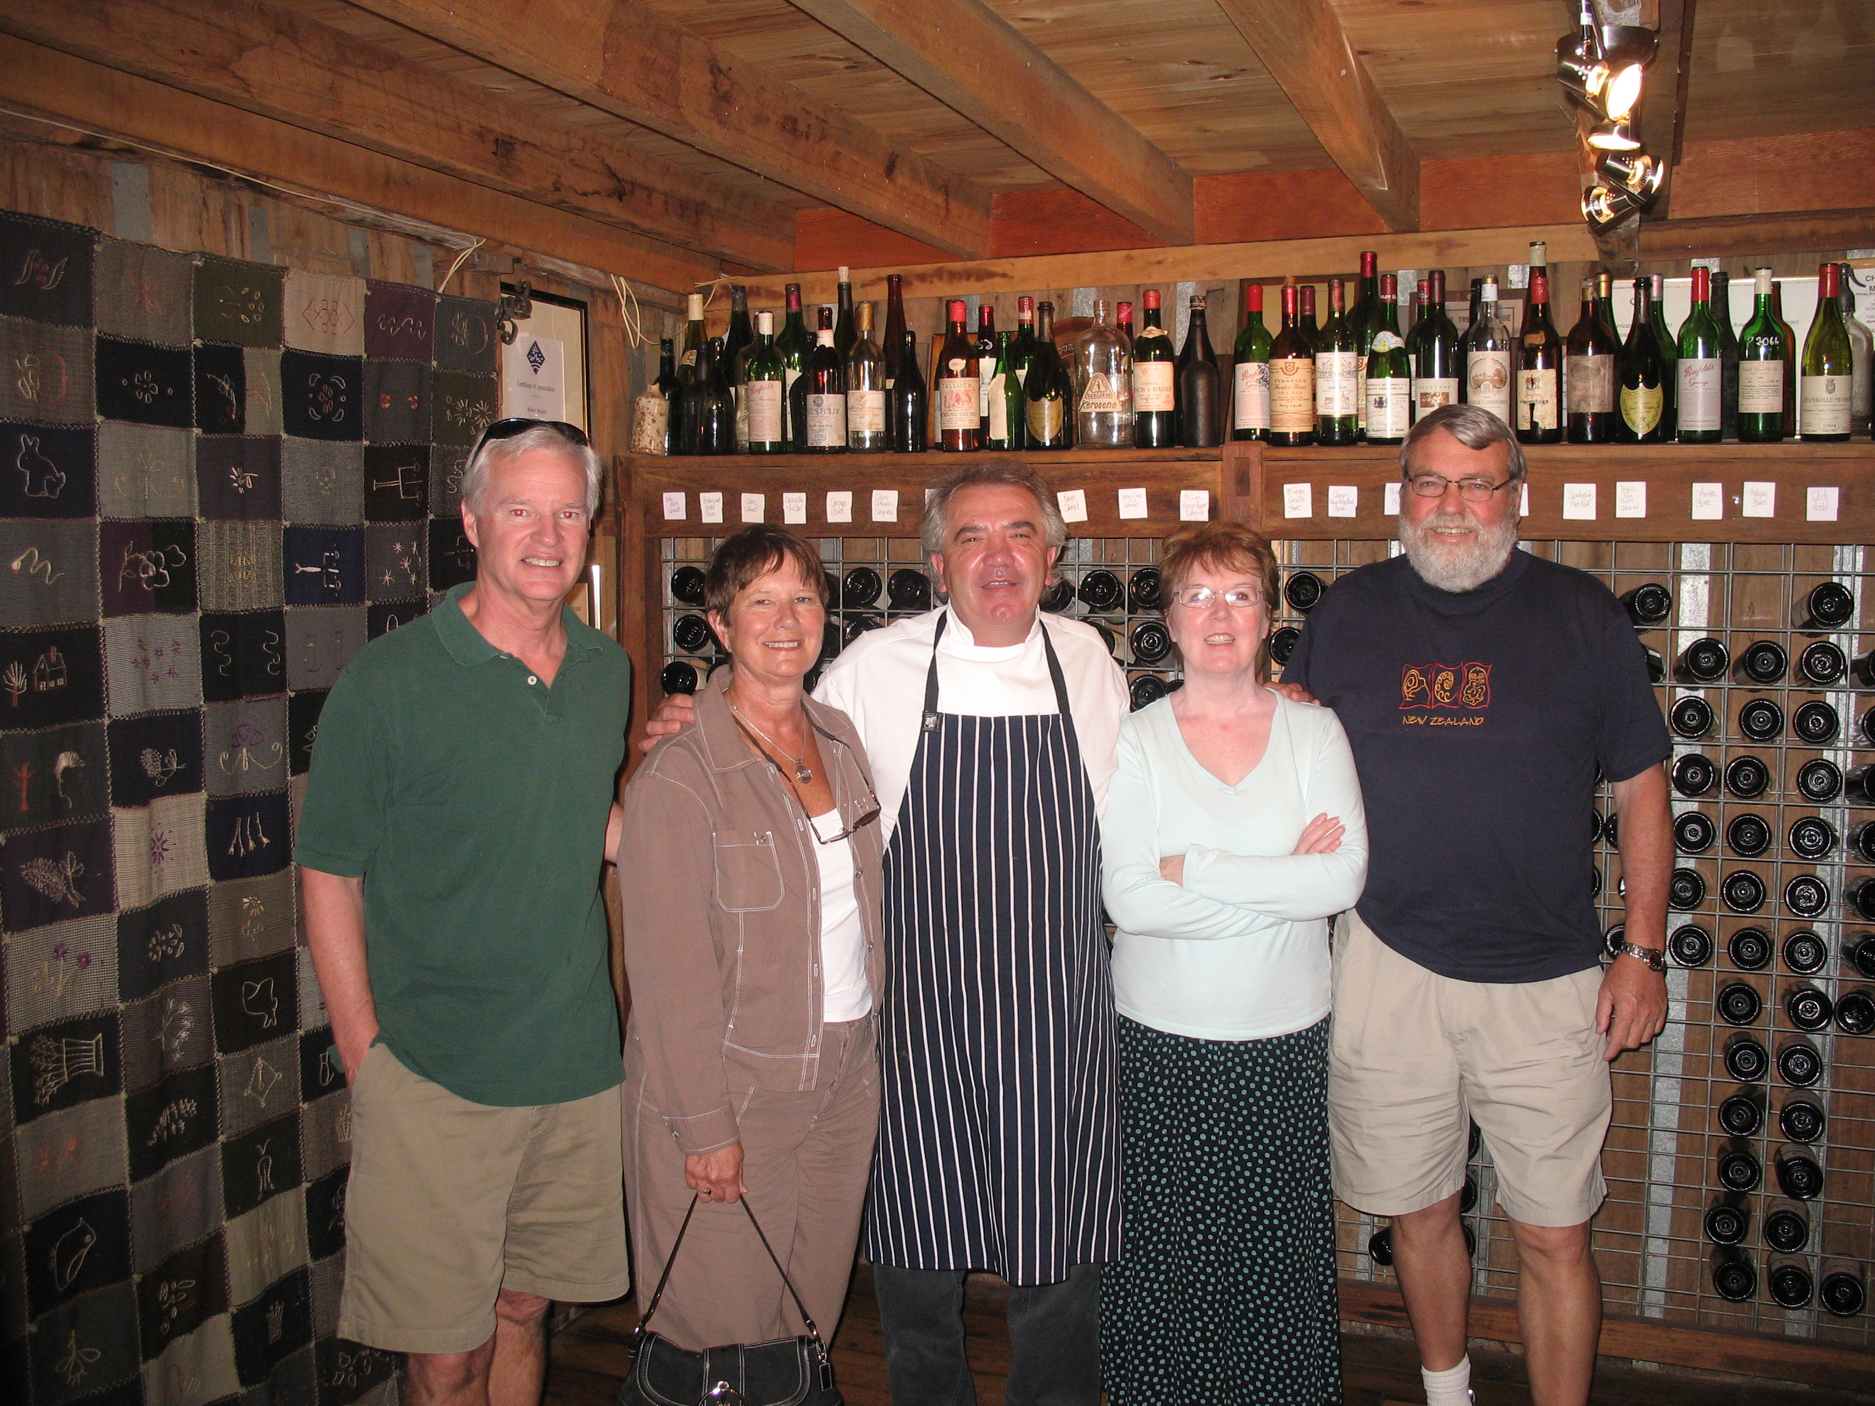

We began by listing on homeexchange.com, and you can find us there under listing 41384. The basic deal is that you stay in someone’s home while they are staying in yours. I say “basic” because it is not unusual to have a non-simultaneous exchange, when you stay in each other’s homes at different times (obviously, you each need somewhere else to go while your home is occupied). We have received inquiries from people interested in coming to Hanover for Dartmouth-related reasons, for foliage, for skiing, for summer camps, and simply to see another part of the USA. Exchange offers have come from all around the country and from many foreign countries. We have completed six exchanges so far and are off again to Scotland this summer (with a probable back-to-back exchange elsewhere in Europe), and we have not had a single major problem with the homes we visit or with our guests. If you can use airline miles, have your accommodations and car provided (cars are usually exchanged as well), and are even free to eat meals at “home” when so desired, your travel budget can be expanded to include lots of trips and lots of activities on those trips.
Most recently Brigid was successful in arranging three consecutive exchanges in New Zealand and Australia. We started in early December in a gorgeous suburb of Auckland (Devonport), on the water and a short ferry ride from the city. Contrary to what most people do, we stayed our entire month on the North Island; there was so much to do there that we figured we would come back to the South Island on a future trip. We found New Zealand to be a marvelous country, clean and unlittered, with an extremely eco-conscious and outdoors-oriented population. Unlike the Native Americans, and what we later saw with the aboriginal people in Australia, the indigenous Maori population seems to be well respected and integrated. The scenery, even though North Island is generally thought to be less scenic than South Island, was beautiful, running the gamut from wild volcanic ocean beaches (one where “The Piano” was filmed), long and deserted sheltered beaches, mountains (under the New Zealand definition), and “thermal areas” where steam escapes from underground hot spots and the air has a vague sulphur odor. We found that celebrating the holidays in a foreign country was almost a relief, as Christmas in particular is not the commercialized version that we see in the USA. Classmate, fraternity brother, and general buddy Jim Danielson and his wife Carol joined us about halfway through our New Zealand stay and we had many adventures, including a jet boat ride on the river, wine country touring (and a little tasting), and even Cirque du Soleil which was making an Auckland appearance.
In early January we flew up to Townsville, Australia, in Queensland and a jumping-off point for the Great Barrier Reef. Our second exchange here was actually two places, first a wonderful waterfront condo on the mainland, and then an unbelievable vacation home on Magnetic Island, part of the inner portion of the Reef. You can check out this latter place on magneticislandholidays.com.au, it was wonderful and included our own private snorkeling beach (the picture is of Jim and me in our “stinger suits”, protection against the local jellyfish population). Our adventures here included a trip out to the main reef where I fulfilled a long-held ambition to dive on the Reef (I think that’s why I got my dive card 25 years ago), feeding the wild wallabies, and a visit to a game park where we held koalas (cute), pythons (scary), and crocodiles (very small). Jim and Carol went fishing with Barnacle Bill, and reported that the only thing dirtier than Barnacle Bill’s boat was Barnacle Bill himself.
We then flew back down to Sydney, where for our third exchange we stayed in a town (Davidson) that was a 20 minute bus or ferry ride to Sydney harbor. We were actually there on Australia Day, somewhat similar to our Independence Day and celebrating when Captain Cook dropped anchor in Sydney Harbor. The Opera House is everything they say it is, and we liked Sydney as much as any city we have visited. We also liked Australian wine country, which we managed somehow to get to before the Danielsons had to leave us. Even though we only saw a small slice of it, Australia is also a country of great beauty, from the Blue Mountains to the north shore beaches of Sydney. It was a 28-hour door-to-door trip back home to Hanover, but worth the jet lag.
If it seems that arranging three consecutive home exchanges is a stretch, our Sydney exchange partners are soon to embark on six consecutive exchanges, beginning in Vancouver and ending in Hanover during foliage time (may even be during our mini weekend). Brigid is now working on a three-way exchange, whereby we go to Europe, the Europeans go to Manhattan, and the Manhattanites come to Hanover for summer camp at Norwich’s Montshire Museum. Simple or complicated, we have found this to be a great way to travel. We have made friends, met local friends and neighbors of our exchangers, and felt a part of the communities we have visited. Do any classmates have homes in exotic locales which they would like to exchange for a few weeks in Hanover? Check homeexchange.com, listing 41384. It’s a great way to travel.
Murph

Ed Keible (8/07):
By way of news, I was recently appointed/elected to the Board of Overseers for Thayer School, so I guess I will be in Hanover a little more often to look after my new responsibilities.
Hope to see you all soon
Ed Keible
P.S. Congratulations!

College news:
President Wright has made several trips to visit wounded veterans at both Walter Reed and Bethesda Naval Hospital over the past two years. He has been a leading advocate for educational counseling for these heroic young men and women and has worked with the American Council on Education (ACE) to develop a program to encourage them to pursue higher education.
NEW YORK TIMES - 5/23/2007 Edited by me. See web-site for full text)
The Few, the Proud, the Dartmouth-Bound
By: Tamar Lewin
http://www.nytimes.com/2007/05/23/education/23face.html
When he first met James Wright, the president of Dartmouth College, two years ago, Samuel Crist was in a hospital bed at the National Naval Medical Center in Bethesda, Md., recuperating from gunshot wounds from a firefight in Falluja, Iraq.
"I was pretty heavily medicated, so my memory is a little bit foggy, but he was visiting people and asking about their experiences in the war, and pushing people to get an education," said Mr. Crist, 22, who grew up in Lafayette, La. "He said he'd been a marine, too, and he'd gone to college after he got out as a lance corporal, the same rank I separated at."
That hospital visit changed things for both Mr. Crist and Mr. Wright: On Mr. Wright's advice, Mr. Crist enrolled in college courses in Texas, and next fall, will transfer to Dartmouth.
Mr. Wright, 67, meanwhile, has made eight more visits to wounded veterans at Bethesda and at Walter Reed Army Medical Center in Washington, and, with the American Council on Education, started a program to provide individualized college counseling to seriously injured veterans.
Mr. Wright said news coverage of the 2004 battle for Falluja spurred him to think about what he could do for wounded veterans.
"I worried about the injured servicemen and how much suffering there was," said Mr. Wright, who spent three years in the Marines in California, Hawaii and Japan, but never saw combat. "So I decided that I'd like to go down to Bethesda and visit them, and see what I could do to encourage them to go back to school."
He remains a rarity: a former marine with a blue-collar background heading an Ivy League university. … the student body, he said, includes no veterans of the Iraq war. To the few Dartmouth alumni serving overseas, Mr. Wright sends care packages, including maple-sugar candy and a book of Robert Frost poems.
Mr. Wright is delighted at the prospect of having a few former marines on campus next fall. One applied early decision, and was accepted, entirely apart from the program. One came through a counselor in the new program. And Mr. Crist wrote to Mr. Wright after their meeting, developing the relationship that led to his transfer plans.
This month, Mr. Wright invited Mr. Crist and one of the others to visit the college. "They both want to study Arabic," he said. "They're not likely to be the regular run-around-the-bonfire freshmen. It's going to be a different culture for them, but this is a very open, egalitarian campus, and I think it will be a good for them and for Dartmouth."

Dartmouth President Named a "New Englander of the Year"
New England Council recognizes James Wright for leadership in higher education and educational counseling services for U.S. veterans of Iraq and Afghanistan

Dartmouth College celebrated another successful fund-raising year with $159.1 million in charitable gifts during the fiscal year that ended June 30, 2007.
The Dartmouth College Fund (DCF) raised a record $39.1 million in unrestricted gifts, a 27 percent increase over the $30.7 million raised last year. The percentage of donors remained steady at 51 percent. Contributions to the DCF account for approximately one out of every ten dollars in the College's annual budget
Eighty percent of the Dartmouth Class of 2007 made donations to the College, breaking the participation record held by the Class of 2006, which stood at 73 percent. The students raised $15,145, just shy of last year's total.

2007 OOH Minis:

Class of ’65 Florida Mini-reunion, January 2007

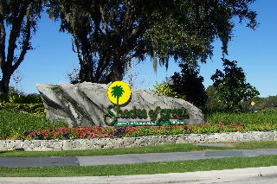 The first Class of '65 OOH (out-of-Hanover) Mini-Reunion weekends staged in Florida was a great success, enjoyed by all in attendance! Thanks to Donn Barclay for his efforts as our local go-to area rep, Robbie Robinson for planning help, and Bob Blake for overall coordination. We stayed at the terrific Shades of Green Resort on Disney World, with it’s comfortable facilities and great location, enjoyed visits to various Orlando area tourist sites, and gathered for a delicious and fun Class Dinner at a superb Italian restaurant. More details and photos on our website: http://www.biggreen65.com/

Overall, the main attraction was companionship and camaraderie, even though the group was on the go with many things to do and see. The highlight of the weekend was the delightful Class Dinner evening of reminiscing and story-telling, reliving our days on campus and since. We were especially delighted to have as special guests Dean Thad (D'49) and Polly Seymour, who now live in the Orlando area where Thad still teaches English at Rollins College, where he served as President.

The attendees all agreed this particular venue is worth re-visiting, and so Orlando will have the inside track for our 2009 OOH Mini. Plan now to join your classmates there! This time there might even be time to try out the two PGA championship golf courses!

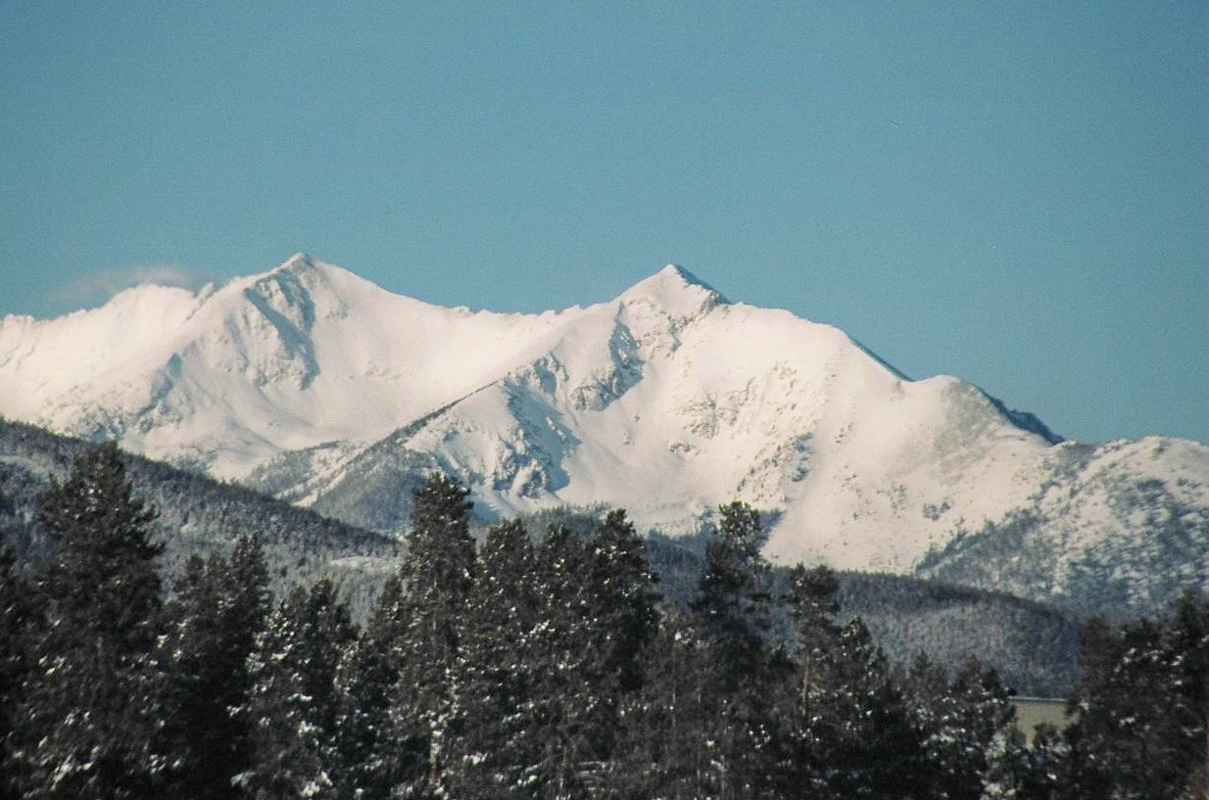

1965 Vail Mini and CarniVAIL - 2007 Is An Outstanding Success!
There are few Dartmouth events to equal the 65's Vail Mini Reunion and CarniVAIL experience of March 1-5, 2007. Over 4+ days, some 200 Dartmouth/Tuck alumni and friends, including a large contingent of 65s, family and friends, gathered in Vail, Colorado to ski, converse, party and discuss some serious subjects. The largest family contingent by far was led by Bill Webster with his group including 3 sons (Bill III, Scott, Tim); 2 brothers Pete "7(Tom '65A and Pete ‘71); Scott's friend Elana; and his friend Dave Morgan with wife Barbara and daughter Elizabeth '00. Other 65s included Ted and Marcia Atkinson; Jim Aiken and his daughter Kate '93, Jim's son and Kate's beau who is also a Dartmouth grad; Chuck and Gretchen Lobitz plus Chuck' brother John '67 and his wife; Sue Bloch and her daughter Rebecca (husband Rich was off working, and son Michael was expected but had to cancel due to weather related flight problems); Norm and Ellen Christianson; Roger Hansen; Tucky and Gabriel Mays; Marshall Wallach; Linda and Steve Waterhouse with friends Steve Cheheyl '67 and wife Maureen.
There was lots of good skiing and many lectures, dinners and entertainment. Go to our superb web-site www.bigreen65.com to see more details.
For all who attended, the 1965 Vail Mini Reunion/CarniVAIL - 2007 was an exceptional weekend, and will go down in history as matching up to any of Hanover's historical Carnivals of the past, while adding to it's own legend! Come join us Feb 28 - Mar 3, 2008 for our next adventure in the history of Class of 1965 Mini Reunions and the Dartmouth/Tuck Winter CarniVAILs....
Regards, Steve and Linda Waterhouse, Co-Chairs of the 1965 Vail Mini Reunion

STAG GOLF WKENDS – LOOKING BACK – LOOKING AHEAD! (Bob Blake)
The spring Scottsdale Stag Golf Weekend was a great success, with two foursomes enjoying great golf, great food, and classmate camaraderie in Arizona’s Valley of the Sun. Thanks to Tucky Mays and Punch Lochridge the course selection and logistics were first-rate! The next one is being planned for September 2008, in Bend, Oregon, by Tucky and Ron Knapp. See our Class website for ongoing information: http://www.biggreen65.com/.

HAPPY BIRTHDAY! – 1965 TURNS 65! (Bob Blake)

SAVE THE DATE – CLASS BIRTHDAY CELEBRATION

MAY 1-5, 2008 – WASHINGTON, DC
Ready or not, members of the great Class of 1965 are about to face and pass a major milestone: attaining the golden age of 65! Not only are we long eligible for AARP cards, but also now we’re in range of Medicare cards, and all the opportunities and questions that come with them! Above all, this is a time to look forward to, to celebrate, and perhaps, as we reflect, a time for some moral support! So, in the grand tradition of recognizing milestones, the Class of 1965 Executive Committee (demonstrating the wisdom of advanced age!) is announcing plans for a celebratory weekend in Washington, DC, to bring classmates and their accompanying S/Os together to recognize this significant life achievement! We hope widows of deceased classmates also will join us!
Note on your calendars the weekend of Thursday, May 1 through Monday, May 5, 2008, and look for more details shortly by mail, email, and on our fabulous website: http://www.biggreen65.com/. The Class event focus will be Friday evening to Sunday afternoon, with the extended room block for those who want a few extra days in DC.
A core 65th Birthday committee of Ted Bracken, Don Boardman, Rich Bloch, and Bob McConnaughey (Bob Blake and Ken McGruther ex-officio) is in the early planning stages. They are inviting classmates from greater DC (aka, DC, DE, MD, VA) to join in the process, and welcome ideas/suggestions from all classmates to make this a truly outstanding event!
To help, or to share ideas, contact Ted Bracken at: bracken@jhu.edu, or (B): (202) 663-5926; (C): 202-669-7702. For publicity purposes, send your email addresses (add or change) for the Class email list to Bob Blake: bob.blake.65@alum.dartmouth.org.

